**Part 3**

**1. Metric Used for Reconstruction Error – Mean Squared Error**

* The Mean squared Error is calculated individually for each channel i.e **red, green and blue. $${MSE}_{channel }=\frac{1}{n} \sum_{i=1}^{n}{{({recon_channel}_{i}-{original_channel}_{i})}^{2}}$$** where,  
   ***recon_channel*** : is a colour channel from reconstructed image.  
   ***original_channel*** : is a colour channel in original image.  
   ***n*** : is the number of pixels in the image.
* The Combined error is calculated as the average of all three channels. $${MSE}_{average}=\frac{{MSE}_{red}+{MSE}_{green}+{MSE}_{blue}}{3}$$

**2. Reconstructed Images and Error Plots**

* Images are interpolated using a 10x10 averaging filter which averages the neighbouring pixels to estimate the value of the missing pixel.
* For each image, reconstructed images after dropping 15, 30 and 45 percent of pixels are shown.
* The error plot shows the combined reconstruction error along with the errors for each individual colour channel.
* This helps us better visualize the contribution of each channel to the overall error.

**I - lake-forest.rgb**

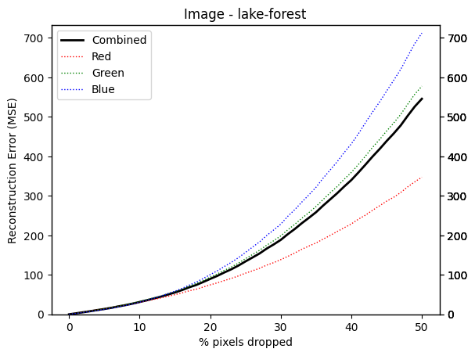

**Reconstructed images**

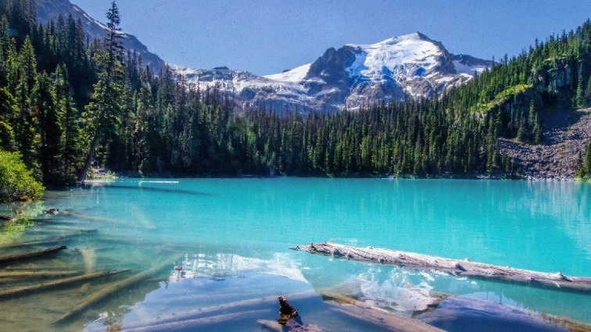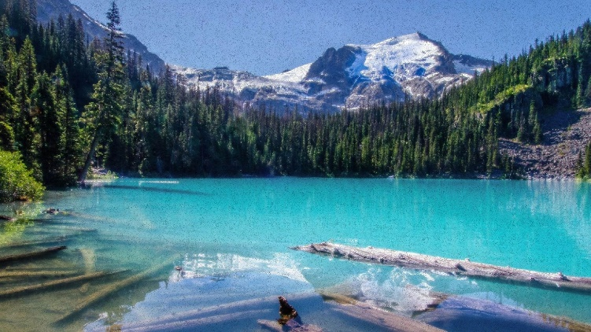 *15% percent pixels dropped 30% percent pixels dropped*

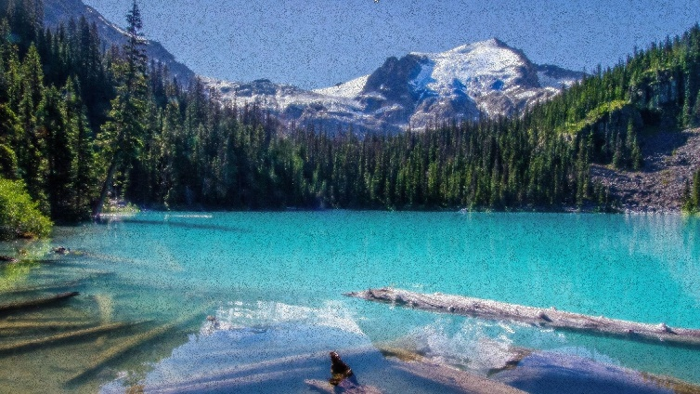 *45% percent pixels dropped*

**II – miamibeach.rgb**

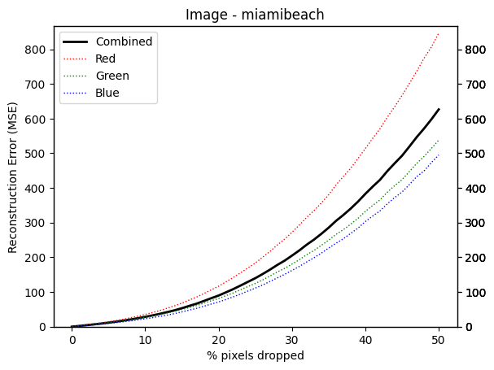

**Reconstructed images**

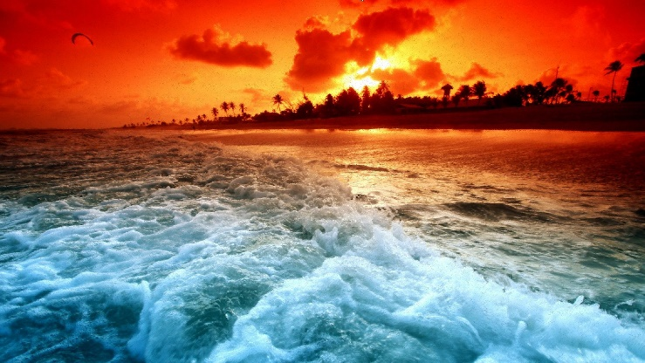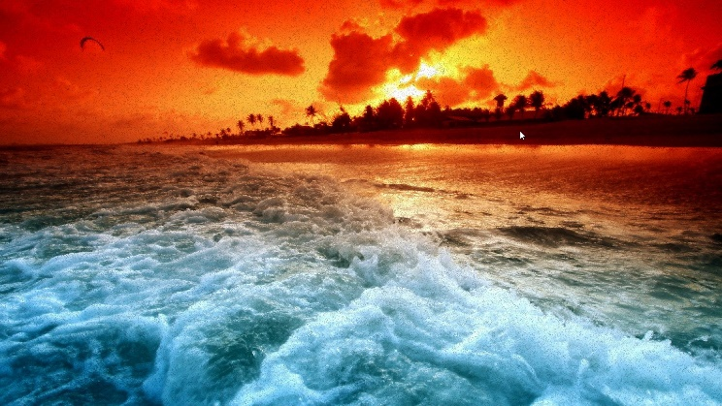 *15% percent pixels dropped 30% percent pixels dropped*

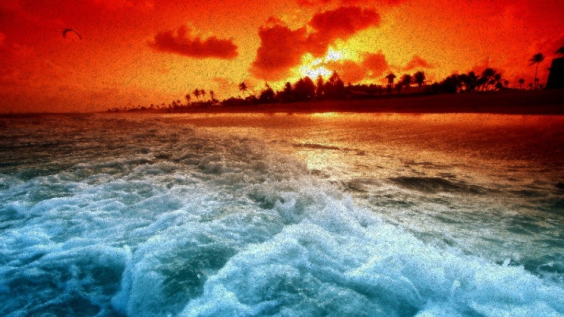 *45% percent pixels dropped*

**III – mountain.rgb**

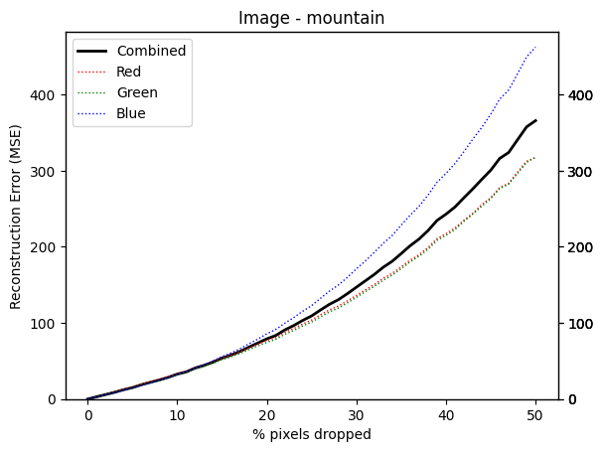

**Reconstructed images**

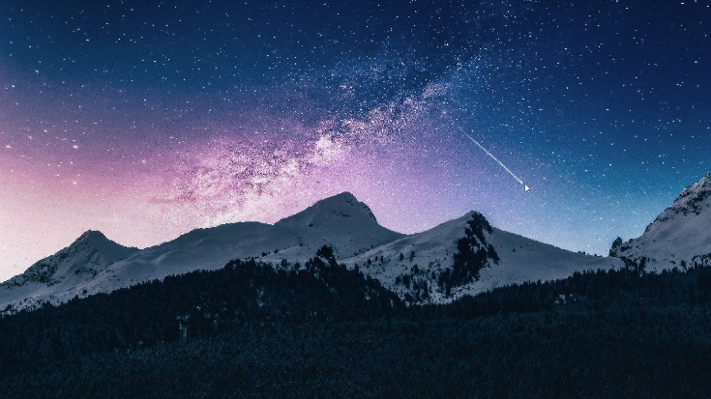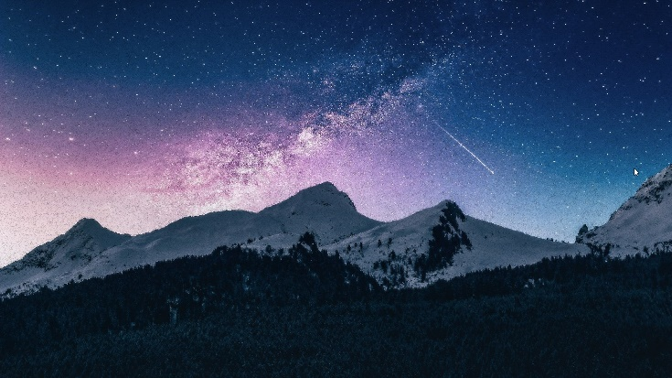 *15% percent pixels dropped 30% percent pixels dropped*

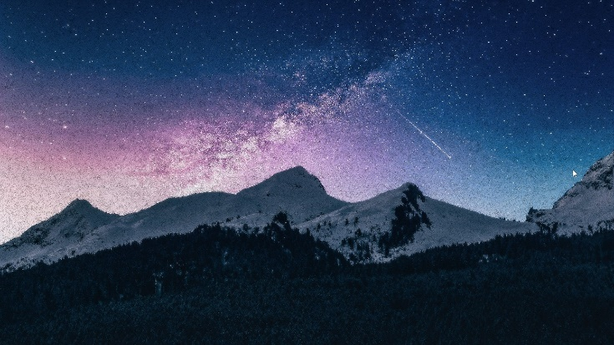 *45% percent pixels dropped*

**III – rubixcube.rgb**

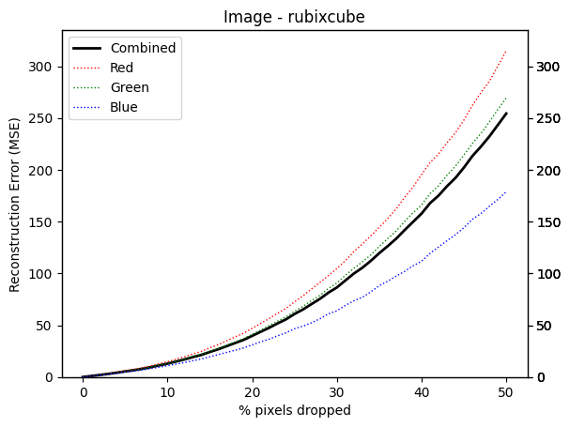

**Reconstructed images**

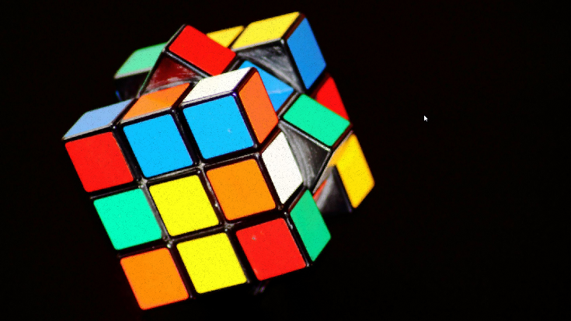 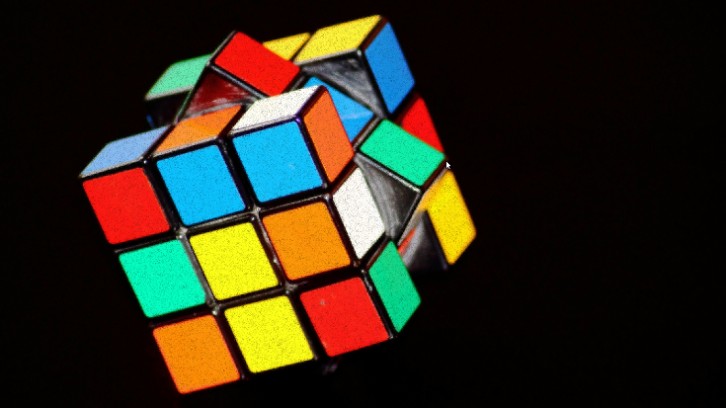  
 *15% percent pixels dropped 30% percent pixels dropped*

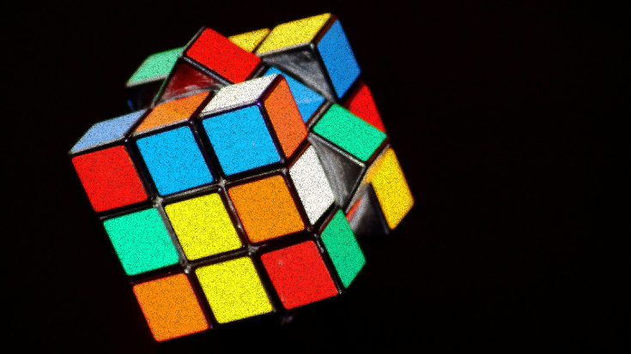 *45% percent pixels dropped*

**V - skyclouds.rgb**

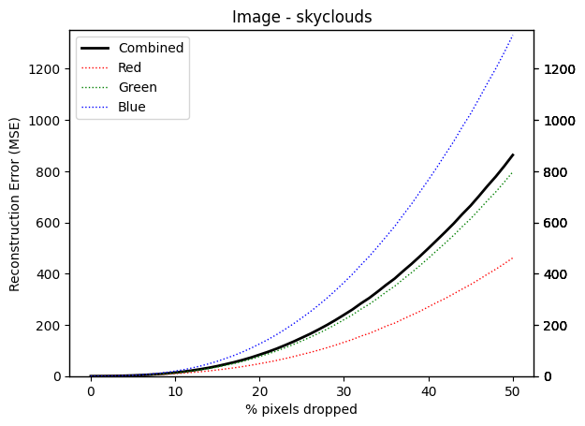

**Reconstructed images**

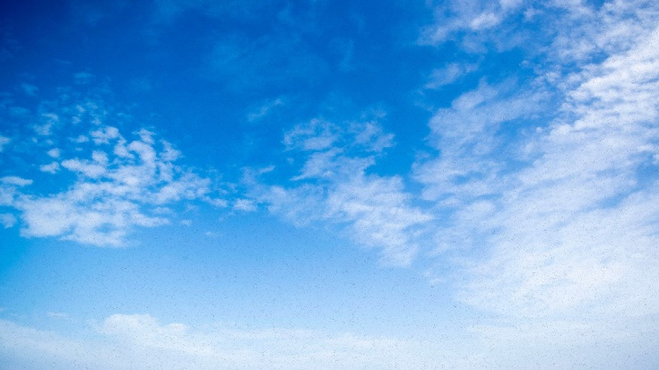 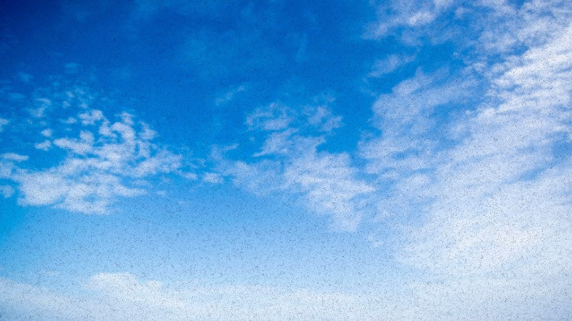   
 *15% percent pixels dropped 30% percent pixels dropped*  
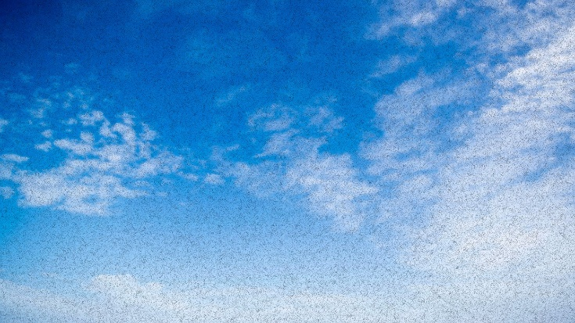  
 *45% percent pixels dropped*

**VI - stagforest.rgb**

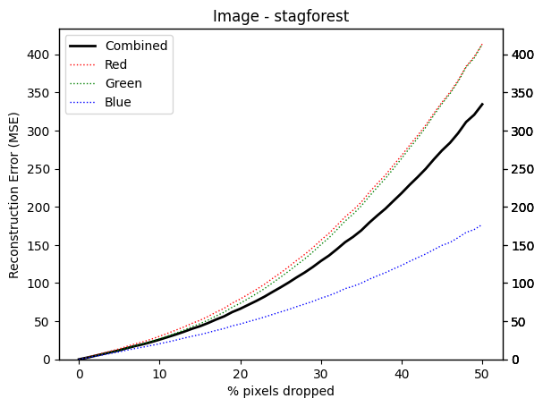

**Reconstructed images**

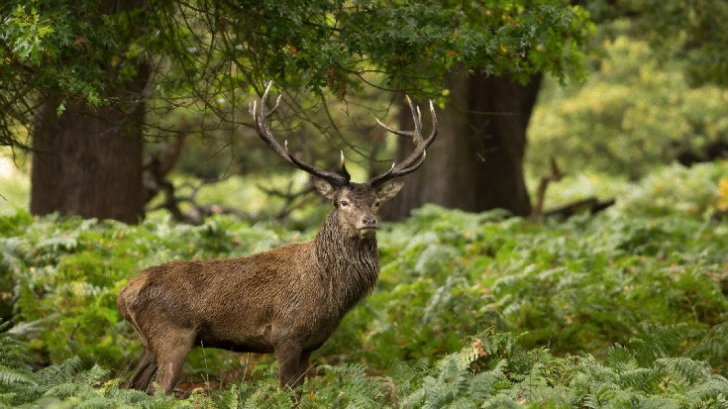 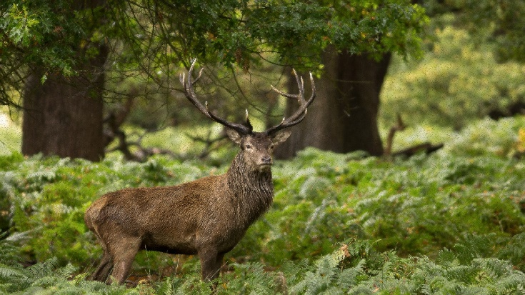   
 *15% percent pixels dropped 30% percent pixels dropped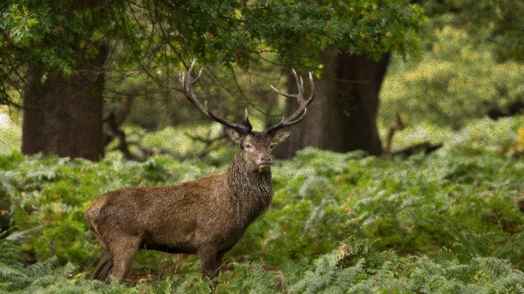 45% percent pixels dropped*

**VII - worldmap.rgb**

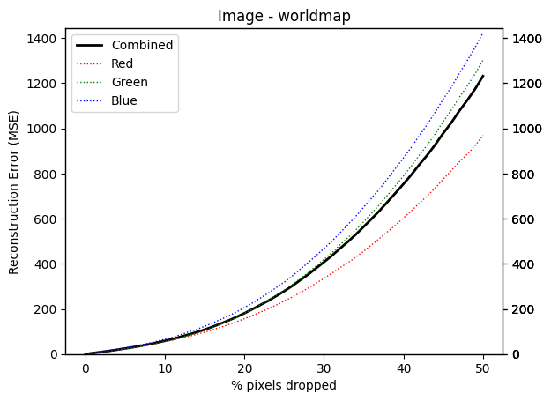

**Reconstructed images**

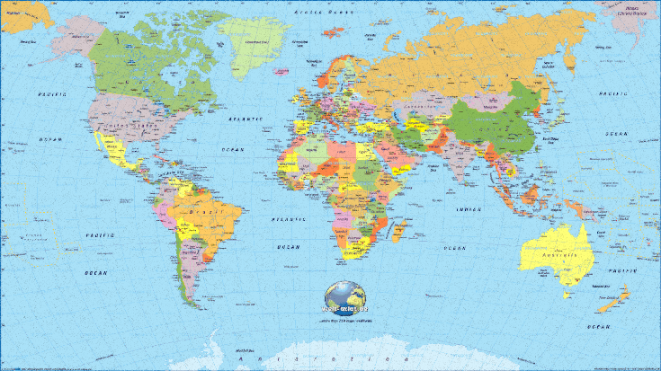 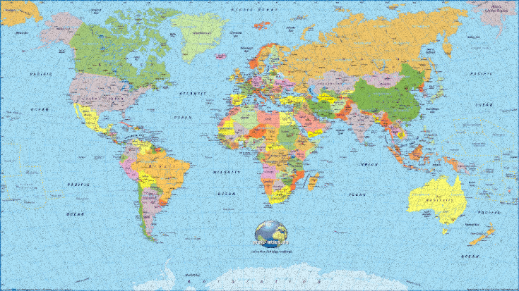   
 *15% percent pixels dropped 30% percent pixels dropped*  
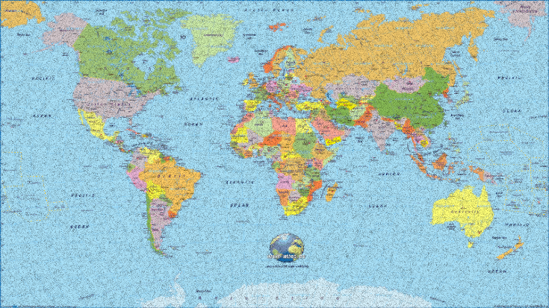  
 *45% percent pixels dropped*

**3. Analysis**

* Image with **lowest reconstruction error** is the image of a **rubix cube**.  
  This is because most part of the image is the same colour i.e., black. This means that essentially for that part of the image, it is very easy to estimate the pixel value by averaging the neighbouring pixels. This reduces the error substantially.  
    
  The parts of the image which contain the rubix cube, have very low frequency of change of colours. They also have very sharp boundaries separating the colours. This makes estimating the pixel within the bounds of a particular colour easy. Therefore, the error is minimum while estimating colours within a particular boundary.  
    
  The filter encounter slightly higher errors at the boundaries where the colours change. This might cause the algorithm to average two different colours and the resulting pixel value might deviate from the original value by a significant amount.  
    
  Overall, the image does not have high frequency patterns and uses plain colours which keeps reconstruction error low for this algorithm.
* Image with **highest reconstruction error** is the image of a **World Map**.  
  The 10x10 interpolation filter implemented by us is a simple filter.  
  The world map image contains a lot of Boundaries. This filter tends to produce poor results when it comes to estimating pixels on a boundary.  
  The image also has a lot of text, which when interpolated using our technique is prone to huge errors. Interpolating text is a pattern recognition problem, one which cannot be simply solved by averaging neighbours.  
  Each character has a separate pattern which is independent of its neighbours. Our filter assumes that there is a dependency between the neighbouring pixels, which is the reason for its poor performance while interpolating text.  
  There is also a lot of high frequency data when it comes to regions where a lot of small countries are packed together in a comparatively smaller region. Depending on the filter size, the algorithm may not be able to interpolate finer details such as borders between countries. It might also paint a region of country A with colours similar to that of country B if a pixel belonging to country A has a lot of neighbours belonging to country B.  
  This image, in essence highlights all the shortcomings of our algorithm when it comes to dealing with high frequency pattern, Edges and boundaries and Abrupt transition in pixel values, especially when the change is pixel value is independent of its neighbours’ values.
* Based on our analysis of the images, images that will lead to a high error and low error can be quantitatively described.

|  |  |
| --- | --- |
| **High Error** | **Low Error** |
| Images with **Fine textures and details** such as intricate patterns, or very small objects. This makes reconstruction using an averaging filter very difficult.  Images where there is an **abrupt transition** in pixel values without a smooth transition. This also shows that the pixels may not be similar to their neighbours, which gives a high reconstruction error based on the algorithm  If an image contains **high levels of Noise**, this algorithm fails. The algorithm might end up interpolating noise and introduce inaccuracies to the reconstructed image.  Image with a lot of **clustered missing regions** will not be interpolated correctly since the number of neighbours available to estimate the missing values would be very low. | Images that have a very **smooth colour gradients** display very low reconstruction error because averaging filter works great in such cases.  Images that **gradual transition between regions** showing a dependency of colours on its neighbouring colours can be interpolated really well.  Images with **Low Noise** show great results when interpolated.  Images in which **missing pixels are sparsely located** will be reconstructed with a low error owing to the presence of plenty of neighbours to average and estimate the missing pixel value. |

**Part 4**

We observe that for each image, the MSE for each channel at ***X%*** pixel drop is approximately ***k*** times the mean of that pixel for that image.

$${MSE}_{channel}=\left[\frac{1}{n} \sum_{i=1}^{n}{{channel}_{i}}\right] *k$$

where,

***n*** : is the number of pixels

***k*** : scaling factor

By observing the graphs for all the images, we can estimate that the value of **k≈5.2, when number of pixels dropped is 50%.  
 k≈0, when number of pixels dropped is 0%.**

Since the Error curve is non-linear, the value of k would also vary non linearly with pixel drop percent. The error curve is a 2-degree curve.

We can estimate

$$k=aX^{2}$$

where,

***k*** : scaling factor  
***X*** : percentage of pixels dropped.

By substituting k=0, X=0 and k=5, X=50, we get an approximate value of ***a* ≈ 0.002**  
  
Therefore, we can substitute ***k***as follows

$${MSE}_{channel}=\left[\frac{1}{n} \sum_{i=1}^{n}{{channel}_{i}}\right] *0.002* X^{2}$$

We can estimate average MSE as $${MSE}_{average}=\frac{{MSE}_{red}+{MSE}_{green}+{MSE}_{blue}}{3}$$

We can observe that the ${MSE}_{average}$ calculated using the above formula closely matches for several images and X values.